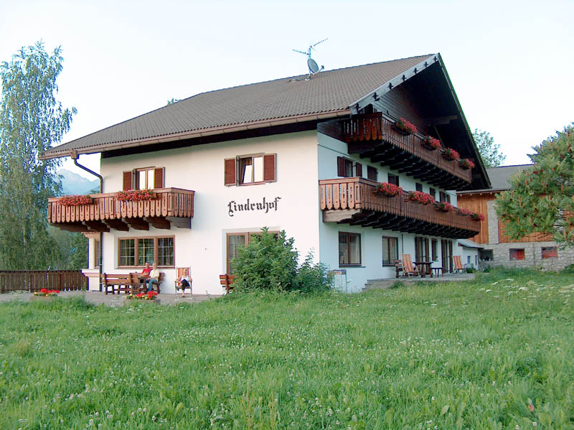
Garni Lindenhof
Familie Mair Johann
Hubenweg Nr. 2
I-39031 Reischach/Bruneck BZ
Pustertal - Südtirol
St. Nr.: MRA JNN 71M18 B220N
MwSt. Nr.: 02720040217
Pec: johann.mair10@pec.sbb.it
IBAN: IT04 O080 3558 2410 0030 4010 337

Reservation
Inquiry

First name
Surname
Address
ZIP and City
Country
Phone
Fax
E-Mail
Number |  | 1-bed stance
Number |  | 2-bed stance
Number |  | Apartment for 2 people
Number |  | Apartment for 6 people
Number |  | adults
Number |  | children
Date of arrival
Date of departure
other desiderations
Send to |  | garni-lindenhof@rolmail.net

